# 2019 ANNUAL REPORT

**CWMS Regional Water Committee**

**Comments from the Chair, Hugh Logan**The Canterbury Water Management Strategy (CWMS) Regional Committee has the job of integrating the region-wide water initiatives that collectively contribute to the goals of the CWMS. The work of the committee over the past year, and the advice and support it has provided to Environment Canterbury, are recorded in the sections that follow in this annual report.

The CWMS is the guiding framework for water management in Canterbury. It has been instrumental in placing Canterbury at the forefront of regional government in the way that freshwater water is managed. Given the multitude of interests, issues and demands that swirl around the use of freshwater, it is a challenge. Freshwater is the lifeblood of Canterbury, socially, economically and environmentally. The past decade has witnessed a generational change in how water is managed, with realization of its sensitivity to pollutants and changing climate, and the importance of healthy water and waterways.

Over the period since the inception of the CWMS ten years ago, much has been achieved – new plans and rules, local initiatives to enhance and protect waters and habitats, new infrastructure to reticulate water and new more demanding goals for the Strategy for the future. But looking after water is an ongoing job. There will be ongoing and new challenges, especially dealing with climate change, pressing forward in management of nitrogenous pollutants, changing land use patterns, and in the short term responding to likely new national standards for water management. The CWMS is up to these challenges and so is the Regional Committee.

This past year has seen changes in the Committee membership, and there will be a further refresh of members in the coming year. As Chair, I would like to thank outgoing members Mayor Winton Dalley (an inaugural member to the Committee, who has retired as Mayor of Hurunui District), Councilor Nicole Reid, and Vicky Southworth. They have been great and valued contributors to our work.

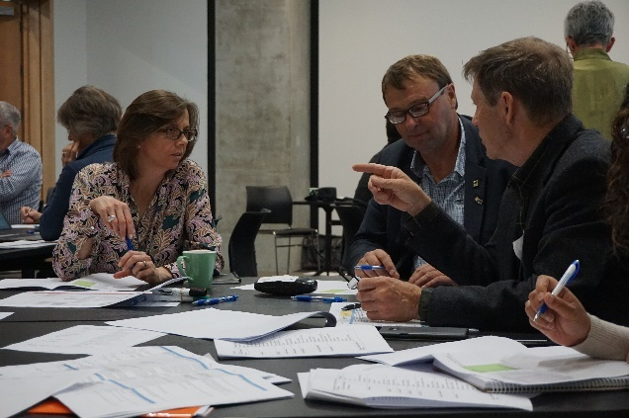

Hugh Logan working on the CWMS 2025 and 2030 targets with Caroline Hart (Environment Canterbury) and Chris Allen (Federated Farmers and Ashburton zone committee member)

## Key Achievements 2019

**Evolution of the CWMS – Interim Targets 2025 and 2030**The CWMS is evolving as our understanding improves, our expectations of each other changes and new players become interested in improving the way freshwater is managed in Canterbury. When the Regional Committee reported on progress to deliver the CWMS in the 2017 Targets Report the Committee recommended populating the Strategy with interim targets for 2025 and 2030. This recommendation was supported by the Mayoral Forum and Environment Canterbury and resulted in the Regional Committee, with the help of many others developing new interim targets for 2025 and 2030. The Mayoral Forum approved the proposed interim targets in May 2020.

**Measuring Progress - Targets Report 2019**

The CWMS establishes a “direction of travel” for freshwater management in Canterbury. Progress is measured against the targets every two years. The Committee oversaw the development of the 2019 Targets Report.

The 2019 Targets Report is the 4th targets report that has been published since 2010.

A key finding of the 2019 Targets Report, like the 2017 Report, is that significant effort is being made by a variety of agencies, groups and individuals throughout Canterbury. But we are yet to see these efforts translated into real and significant outcomes.

We expect there to be a time lag as natural systems adjust and we expect that we will need to adapt and adjust our actions in response to improved understanding, monitoring information and technology – but it is frustrating.

We would like to acknowledge the effort that has been made, particulalry in the rural sector with the introduction of Farm Environment Plans and the independent auditing system. We shouldn’t underestimate the changes that are taking place in rural sectors to improve environmental performance. The path is clear - but there is still a long way to go.

In the next couple of years we expect to see an increase in the pace of change in other target areas as councils respond to government directions on freshwater, drinking water and biodiversity. Territorial Authorities will also be required to improve the quality of their stormwater discharges to comply with new consents and the 2025 Kaitiakitanga targets will provide real focus for zone committees to deliver mahinga kai projects in their zone.

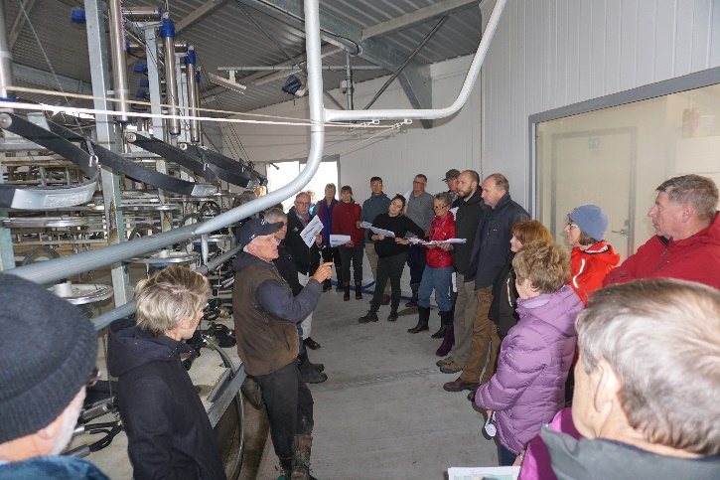

Members of the Regional Committee, Selwyn Waihora, Ashburton and Christchurch West Melton zone committees visited a dairy farm to undertake a mock FEP audit to better understand what is involved – May 2019

**Environmental Limits - Farm Environment Plans and Audits**A significant effort over the first ten years of the CWMS has been to put in place the *Land and Water Regional Plan* that sets environmental limits and a regulatory regime to govern the way water is managed in Canterbury. The Plan requires many farms to have a consent and a Farm Environment Plan (FEP) that are independently audited. There are now 1500 farms managed under irrigation scheme authorisations, and a further 1000 applications for consent have been received. The focus is now on ensuring FEP audits are undertaken and they get a passing audit grade.

The Regional Committee took the opportunity to visit a dairy farm north of the Rakaia to find out what FEPs and audits were all about and how they are beginning to change the way farms are being managed in Canterbury.

**Ecosystem Health and Biodiversity - Regional Biodiversity**Across the region zone committees have allocated $1million to approximately 80 Immediate Steps Biodiversity Projects. Projects funded include protecting old willows for endangered Long Tailed Bat colonies (OTOP), to building artificial islands that provide protection from predators for breeding braided rivers birds (HW) to fencing covenants (BP) and planting around spring heads (SW).

The Regional Committee oversees funding for three multi-year projects that focus on weed and predator control on braided rivers, fish barriers and weed control in the wetland margins of Te Waihora. The committee visited the “Weed Strike Force” at work on the edges of Te Waihora and heard how thinking differently has resulted in a significant increase in the area cleared of willows.

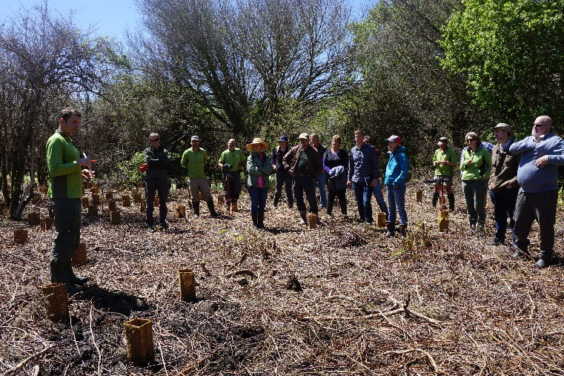

The Regional committee and Selwyn Waihora zone committee visited the Weed Strike Force on the edge of Te Waihora - November 2019. By thinking differently this DOC/ECan project has controlled weeds on 790ha for the same cost as it once did on 400ha

**Ecosystem Health and Biodiversity - Fish Screens**Improving the effectiveness of fish screens has continued to be a priority for the committee. It is fair to say that there are no “quick fixes”. There are now three projects underway – one on the behaviour of native fish species as they approach screens lead by NIWA, another on effective designs for new screens lead by Irrigation New Zealand and the third on how to improve the performance and compliance of existing structures lead by Environment Canterbury.

Since 1967 there has been rules that require fish screens on water takes. There are thousands out there, but little has been done to determine how effective they are. It was disappointing to hear that of the 32 sites Environment Canterbury visited in 2019 none were compliant with NIWA guidelines.

Improving the performance of fish screens has the potential to make a big difference to Canterbury’s sport fishery and native fish species. We will continue to work with Environment Canterbury, irrigators, NIWA DOC and Fish and Game to improve existing screens, the design or new screens and our understanding of various fish species behaviour when they encounter a screen.

**Recreation and Amenity**

The 2019 Target Report tells us progress is slow in this area. The Regional committee explored a theoretical approach to recreation and amenity with the help Lincoln University. This approach has proved to be of limited value. The committee is now turning to the zones to look for practical projects that deliver recreation and amenity values as well as continuing to improve water quality and ensure the way water is allocated takes recreation and amenity values into account.  
 

**Challenges/Opportunities 2020**

* Hold & grow the **collective commitment** to deliver the CWMS
* Focus on the **delivery of the 2025 targets**
* Continue to work with ECan to ensure **monitoring/reporting information** provides communities with the information they need
* Align and adapt to **Central Governments Freshwater Initiatives**
* Maintain momentumduringa period of **change**

**The Regional Committee**

The Regional committee is a committee of Environment Canterbury. The purpose of the committee is to;

1. Monitor the progress of the Canterbury Water Management Strategy across the region; and
2. Provide advice to Environment Canterbury on regional issues.

The membership includes community, Rūnanga, Te Rūnanga o Ngai Tahu and council representatives. Each of the ten zone committees are also represented. The Canterbury District Health Board, Ministry for the Environment, Ministry of Primary Industries have observer status. The Department of Conservation also attends.  
  
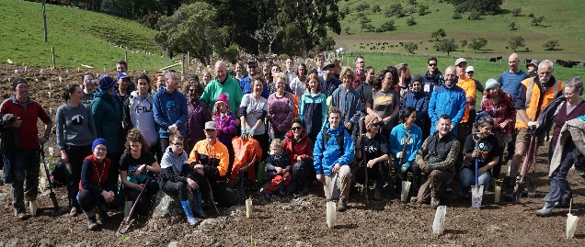Community planting day – Koukourarata September 2019

**Committee Membership**  
As of 31 September 2020

**Ngāi Tahu Representatives**

Rebecca Clements – TRONT  
Vacant – Rūnanga North Canterbury  
Vacant – Rūnanga Mid Canterbury  
Vacant – Rūnanga South Canterbury

**Council Representatives**

Mayor Winton Dalley - North Canterbury DC   
Cr Nicole Reid – Mid Canterbury DC  
Cr Sara Templeton - Christchurch City Council  
Peter McIlraith – South Canterbury DC

**Environment Canterbury**

Cr Peter Scott – ECan  
Cr Claire McKay - ECan

**Community Representatives**

Hugh Canard  
Jane Demeter  
Ross Millichamp  
Vicky Southworth

**Zone Representatives**

Cr Stuart Wilson – Ashburton  
Rima Herber – Banks Peninsula  
Les Wanhalla – Christchurch West Melton  
John Preece – Hurunui Waiau  
Ted Howard – Kaikōura  
Barney Hoskins – Lower Waitaki  
Phil Driver – OTOP  
Benita Wakefield – Selwyn Waihora  
Vacant – Upper Waitaki

**Central Government**

Loretta Dobbs & Phil Kirk – MPI  
Nick Vincent – MFE  
John Benn – DOC  
Alistair Humphrey - CDHB